Ambient Systems
Product Requirements Document
Feb 28, 2021
Version: 01

Intro & Goal

Ambient’s goal is to empower building owners to easily manage the indoor climate. Others in this space are mostly focusing on optimizing a single goal, such as reducing energy costs. Ambient’s end-to-end hardware stack, dashboard, and optimization model leverage latest innovations in machine learning to manage multiple critical yet competing priorities.

Who it’s for?
- Facility Managers/Operators
- Building Owners

Why built it?
- Managing indoor climate is becoming increasingly complex
- Competing priorities are difficult to balance (e.g., reduce energy costs but meet required air quality standards)
- Indoor air quality is increasingly important with increasing air pollution and indoor pathogens
- One market segment (indoor farms) in particular has very few options available
- Related technologies (IoT and ML) are becoming more affordable

What is it?
- Indoor climate optimization model based on cutting-edge building science
- Enabling hardware: sensors, controllers, and related attachments
- Web-based dashboard

Schematic
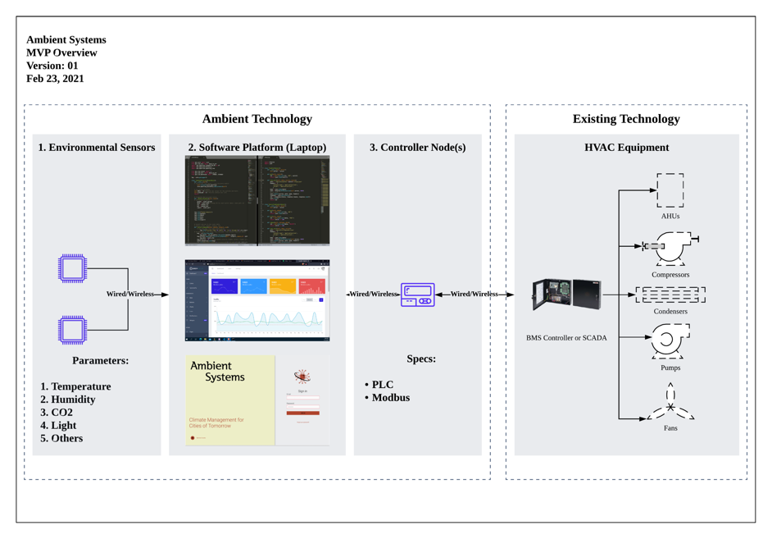

More detailed scope:
- One or more environmental sensors that collect the following parameters: temperature, humidity, CO2, light, and others
- One or more controller nodes that provide instructions to one or more pieces of HVAC equipment
- Software Platform based on the following specifications:
  - Multi-page dashboard
  - Displays data collected by sensors
  - Provides an overview of equipment connected to the system
  - Allows user to send control instructions to the equipment through the platform (e.g., adjust temperature, fan speed, humidifier, purifier, etc.)
  - Provides recommended setpoints for various equipment based on environmental data

List of Key Features:
- Data Analytics:
  - Display data collected by sensors {ID, sensor_reading1, max_ sensor_reading2, time_stamp}
  - Display inventory of equipment {ID, min_set, max_set, current_set, time_stamp}
  - Display indoor map with equipment {ID, room_location, area, height, equipment_located}
- Optimization:
  - Radar Chart: balancing priorities
  - Control chart (scatter graph): identify trends and boundary conditions
- Controls:
  - Input priorities
  - Present optimization recommendations, review, and accept
  - Input equipment settings
  - Send equipment instructions (i.e., set points)
- Connections:
  - Connect sensor readings to dashboard
  - Connect equipment controller node to the dashboard
- Infrastructure
  - User log-in
  - Databases API
  - Notifications: sensor reading, equipment setting
  - Load-balancing
  - Backup

Key Milestones:
Date | Milestone | Description
March 1 | Kick-off | Confirm scope and approach
March 5 | Outsource | Confirm developer resource
March 14 | Launch v0.1 | Launch the product by recording a demo of a basic dashboard for customers (front-end)
March 28 | Release v0.2 | Improvements to front-end (additional charts and pages)
April 11 | Release v0.3 | Core optimization algorithm completed based on public + simulated data  Improvements to front-end (additional charts and pages)
May 2 | Release v0.4 | Data collected by sensors displayed in real-time  Equipment setpoints can be configured  Improvements to front-end (additional charts and pages)
May 17 | Completed MVP (v1.0) | Functional MVP completed for GRIP investment pitch (that can be sold to customers)

Platform Options
Option | Link | Benefits | Cons
From Scratch | N/A | Full flexibility | Resource intensive
Things Board | https://thingsboard.io/ | Ready to use | Cost ($100+ / month)  Setup time  Integration
ThingSpeak | https://thingspeak.com/ | Ready to use | Setup time  Integration

APPENDIX

Different types of graphs and charts:
- https://visme.co/blog/types-of-graphs/

